8-Hour Mediator Update Training

Presented by

November 3, 2025 - 8:30am – 5:30pm
Trainer: Peg MacDougall – VIA ZOOM
$250.00 per person
Psychogeometrics & Trauma
Informed Communication
- Are you a squiggle, box, triangle, rectangle or circle
- Learn how people are attracted to shapes based on their personalities, attitudes, education and experience and what that means for their … and YOUR … communication experience at mediation!
- How to deal with trauma in your mediation
- And Much More! PLUS
Case Law & Legal Updates

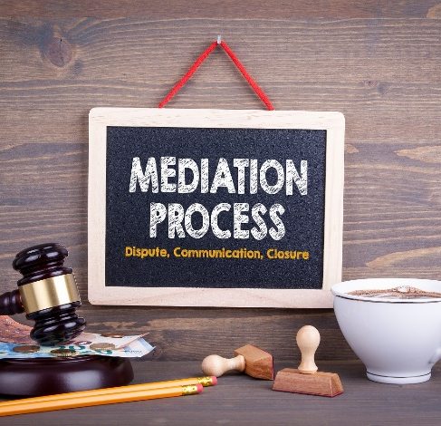


Civil and Domestic Mediators are Welcome!
Gain your 8 hours of mediator
update training, which is required every two years in order to remain on a court roster. You will also be able to add new tools to your
mediator tool box.
Civil and Domestic Mediators are Welcome!
Gain your 8 hours of mediator
update training, which is required every two years in order to remain on a court roster. You will also be able to add new tools to your
mediator tool box.
Civil and Domestic Mediators are Welcome!
Gain your 8 hours of mediator
update training, which is required every two years in order to remain on a court roster. You will also be able to add new tools to your
mediator tool box.
Civil and Domestic Mediators are Welcome!
Gain your 8 hours of mediator update training, which is required every two years in order to remain on a court roster. You will also be able to add new tools to your mediator tool box.
Civil and Domestic Mediators are Welcome!
Gain your 8 hours of mediator
update training, which is required every two years in order to remain on a court roster. You will also be able to add new tools to your
mediator tool box.
Civil and Domestic Mediators are Welcome!
Gain your 8 hours of mediator
update training, which is required every two years in order to remain on a court roster. You will also be able to add new tools to your
mediator tool box.


Registration
Registration
Submit payment and completed
registration form by…
• Mail: To the address below • Phone: 517-485-2274
• Website: www.rsccm.org • Email: To admin@rsccm.org
Submit payment and completed
Registration form by …
Mail: To the address below Phone: 517-485-2274
Website: www.rsccm.org Email: to admin@rsccm.org

Resolution Services Center 516 South Creyts Road, Suite A Lansing, MI 48917



REGISTRATION FORM
8 HOUR MEDIATOR UPDATE TRAINING
$250
November 3, 2025
8:30am – 5:30pm VIA ZOOM
Submit payment and completed
Registration form by …
Mail: To the address below Phone: 517-485-2274
Website: www.rsccm.org Email: to admin@rsccm.org

Name: _____________________________________________________________________________

Organization: _______________________________________________________________________

Address: ___________________________________________________________________________

City: ____________________________________________ State: ____________ Zip: _____________

Email: ___________________________________________ County: ________________________

Telephone Number: __________________________________________________________________

Occupation: ________________________________________________________________________

□ Check made payable to Resolution Services Center of Central Michigan in the amount of $250.00 enclosed.

□ Credit Card, Information Below

I authorize $________________________ be charged to the account listed below:

Card Number _______________________________________________________________________

Exp. Date ______________ Security Code: ______________ Billing Zip Code _______________

Signature ____________________________________________________ Date __________________

Class will be filled on a first-come, first-served basis. Your seat will be reserved once payment is received. Resolution Services Center of Central Michigan reserves the right to retain $100.00 for any cancellations made before October 20, 2025. Refunds after that time will be made only at the discretion of the Center. Full refunds will be made if the training is cancelled for any reason.

Resolution Services Center 516 South Creyts Road, Suite A Lansing, MI 48917

